Basic Geography: AP World History (Fall 2015)
Directions:
Identify, color code, AND label each of the following items on the maps that you have been provided. I have found that in the past, use of colors for different categories is useful in studying. From this point forward you will be expected to know the basic geography of the earth as a basis for understanding human activities on it! All of the information you should need to complete this activity can be found in your “Voyages” textbook as well as in various classroom and Internet resources.

Bodies of Water:
Countries:
- Australia
- New Guinea
- Indonesia
- India
- China
- Russia
- France
- Germany
- United Kingdom
- Saudi Arabia
- Afghanistan
- Pakistan
- Spain
- Turkey
- Peru
- Brazil
- Iran
- Iraq
- Cuba
- Egypt
- Japan
- North Korea
- South Korea
- Argentina
- South Africa
- Mexico
- Haiti
- Netherlands
- Israel
- Palestine
- Mongolia
- Vietnam
- Syria

Man / Woman Made Things: (7)

- Equator
- Tropic of Cancer
- Tropic of Capricorn
- Prime Meridian
- Arctic Circle
- Antarctic Circle
- International Date Line

- Pacific Ocean
- South China Sea
- Red Sea
- Persian Gulf
- Mediterranean Sea
- Baltic Sea
- Indian Ocean
- Atlantic Ocean
- Caribbean Sea
- Huang He River
- Yangtze River
- Indus River
- Ganges River
- Tigris River
- Euphrates River
- Nile River
- Amazon River

Mountains:

- Himalayas
- Andes
- Alps
- Urals
- Caucasus

Deserts:

- Gobi
- Arabian
- Sahara

AP World History- Physical Map

- Water- label each body of water listed in the directions. If it is not already on the map, draw it in and then label it.
- Mountains are already drawn for you- just label them.
- Deserts- research their location and size. Shade them in on the map. Then label them.
- Label the “man made things” (lines) requested in the directions.

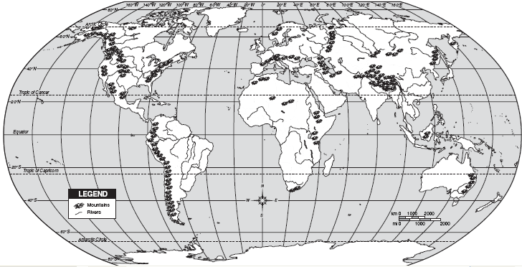

CONTINENTS

- Color each continent a separate color. Pay attention to the official dividing line between Europe and Asia (hint- Ural mountains)
- Label the 20 items asked for in the “Dirt” section of the directions.

