European Power
England  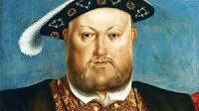  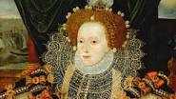 | Henry VIII  - Founded Anglican Church  - 6 wives  - Boosted English Naval power  Elizabeth I  - Daughter of Henry VII  - Solidified Anglicanism as official religion in England  - Encouraged exploration- Canada  - Sponsored Northern Renaissance figures such as William Shakespeare  - Repelled the Spanish Armada- invasion by Spanish
France  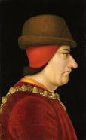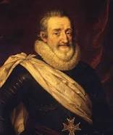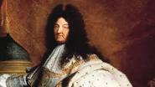 | Louis XI  - Conquered Burgundy  Henry IV  - Ended French Wars of religion  - Allowed Protestantism  Louis XIV  - 1661-1715  - Leader at age 5  - Built large army and navy  - Built the Versailles Place and made France one of the most impressive cities in Europe  - Absolute Monarch  - Involved France in multiple Wars
Holy Roman Empire (HRE)  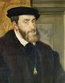 | Charles V (See Crash Course World History 2)  - Habsburg Ruler who also governed Spain  - Encouraged the colonization of the Americas  - Won Wars against the French and the Turks  - Attempted to oppose Martin Luther and Protestantism  https://www.youtube.com/watch?v=MRYzW3BSj0I
Spain  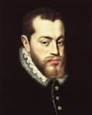 | Phillip II (See Crash Course World History 1 on Spain)  - Son of Charles V  - Failed to conquer England during the Spanish Armada 1588  - Spain becomes the most powerful and wealthiest nation in Europe due to exploitation of the Americas  https://www.youtube.com/watch?v=rjhIzemLdos
Russia  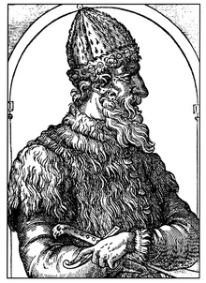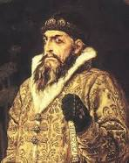  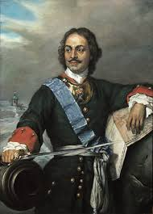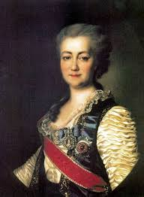  Prussia:  (Small German State)  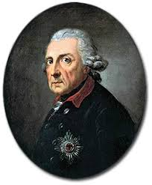  Austria:  The Habsburgs | Ivan III  - Known as Ivan the Great  - Threw off Mongol rule in Russia  - United Russia centered around the city of Moscow  Ivan IV  - Known as Ivan the Terrible  - Used extreme violence to take power over the noble class  Peter the Great:  - Westernization of Russia after being left behind during the Renaissance  - Wins a War with Sweden  - Focus shifts from politics in Asia to Politics in Europe  Catherine the Great:  - Intellectual achievements and Military conquests  See Crash Course World History 1 video for more detail.  https://www.youtube.com/watch?v=etmRI2_9Q_A  Frederick the Great  - 1740-1786  - General and skilled ruler  - Effective absolute monarch  - Won battles over Austria, France, and Russia during the Seven Years War  - Greater dictatorship and decreased freedoms  